

**CAPSTONE PROJECT 1**

**ARCHITECTURE DESIGN DOCUMENT**

**ROOMY SYSTEM**

**CODE:** ARCHITECTURE DESIGN - Version: 1.0

**DATE:** Sep 10, 2018

**Blue Team**

International School – Duy Tan University

**PROJECT INFORMATION**

|  |  |  |  |  |
| --- | --- | --- | --- | --- |
| Project Title | Roomy System | | | |
| Star Date | Aug 15, 2018 | **End Date** | Dec 5, 2018 | |
| Lead Institution | International School, Duy Tan University | | | |
| Project Mentor | Mr. Phan Van Son | | | |
| Project Manager & Contact Details | Phan Van Son  Email: [sonpvs@duytan.edu.vn](mailto:sonpvs@duytan.edu.vn)  Phone: 0905151655 | | | |
| Scrum Master & contact details | Huynh Vu Ha Lan  Email: [huynhvuhalan.97@gmail.com](mailto:huynhvuhalan.97@gmail.com)  Tel: 0989342173 | | | |
| Team Members | Le Hoang Quoc | [quocle28292@gmail.com](mailto:quocle28292@gmail.com) | | 01657708105 |
| Huynh Quoc Nhat | [huynhquocnhat97@gmail.com](mailto:huynhquocnhat97@gmail.com) | | 0905740256 |
| Ho Trung Anh | [hotrunganhht1912@gmail.com](mailto:hotrunganhht1912@gmail.com) | | 09055258534 |
| Huynh Thi Thanh Van | [thanhvandb97@gmail.com](mailto:thanhvandb97@gmail.com) | | 01229444661 |

**ARCHITECTURE DESIGN DOCUMENT**

|  |  |  |  |
| --- | --- | --- | --- |
| Document Title | Architecture Design | | |
| Reporting Period | Sep, 2018 |  |  |
| Author(s) & project | Team | | |
| Date | Sep 2018 | **Fieldname** | Architecture design ver 1.0 |
| Access | Project and CMU program | | |

**DOCUMENT HISTORY**

|  |  |  |  |
| --- | --- | --- | --- |
| Version | Person | Date | Description |
| 1.0 | Team | Sep 7th, 2018 | Draft. |
| 1.1 | Le Hoang Quoc | Sep 20th, 2018 | Fix C&C view, Module view. |

**SIGNATURE**

**Document Approvals:** The following signatures are required for approval of this document.

|  |  |  |
| --- | --- | --- |
| Phan Van Son Mentor |  | Date |
| Huynh Vu Ha Lan  Scrum Master |  | Date |
| Huynh Thi Thanh Van Member |  | Date |
| Le Hoang Quoc  Member |  | Date |
| Ho Trung Anh  Member |  | Date |
| Huynh Quoc Nhat  Member |  | Date |

Contents

**1.** **Introduction:** 1

**1.1.** **Purpose:** 1

**1.2.** **Documents References:** 1

**2.** **Project Statement:** 1

**2.1.** **Project Overview:** 1

**2.2.** **Business Driver:** 2

**3.** **Architecture Driver:** 2

**3.1.** **High-Level Requirements:** 2

**3.2.** **System Context:** 3

**3.3.** **Quality Attributes:** 4

**4.** **Constraint:** 6

**4.1.** **Business Constraint:** 6

**4.2.** **Technical Constraint:** 6

**5.** **High level Architecture** 6

**5.1.** **Component and Connection View (C&C View):** 6

**5.2.** **Module view :** 9

**5.3.** **Allocation view :** 11

1. **Introduction:**

The agile product backlog in Scrum is a prioritized features list, containing short descriptions of all functionality desired in the product. When applying Scrum, it’s not necessary to start a project with a lengthy, upfront effort to document all requirements. Typically, a Scrum team and its product owner begin by writing down everything they can think of for agile backlog prioritization. This agile product backlog is almost always more than enough for a first sprint. The Scrum product backlog is then allowed to grow and change as more is learned about the product and its clients.

* 1. **Purpose:**
  + Provide a prioritized features list, containing short description of all functionality desired in the product.
  + Lists everything that the product owner and Scrum team feels should be included in the software they are developing.
  1. **Documents References:**

|  |  |
| --- | --- |
| **No** | **References** |
| **1** | Product Backlog Document |
| **2** | Project Plan Document |

1. **Project Statement:**
   1. **Project Overview:**

* Project name: Administrative Documents for Office.
* Development team: Only3 Team

|  |  |  |  |
| --- | --- | --- | --- |
| Full Name | Phone | Email | Position |
| Huynh Vu Ha Lan | 0989342173 | [huynhvuhalan.97@gmail.com](mailto:huynhvuhalan.97@gmail.com) | Scrum Master |
| Huynh Thi Thanh Van | 01229444661 | [thanhvandb97@gmail.com](mailto:thanhvandb97@gmail.com) | Member |
| Huynh Quoc Nhat | 0905740256 | [huynhquocnhat97@gmail.com](mailto:huynhquocnhat97@gmail.com) | Member |
| Le Hoang Quoc | 01657708105 | [quocle28292@gmail.com](mailto:quocle28292@gmail.com) | Member |
| Ho Trung Anh | 09055258534 | [hotrunganhht1912@gmail.com](mailto:hotrunganhht1912@gmail.com) | Member |

**Table 1: Team Member**

* 1. **Business Driver:**
* **Project Definition:**
  + - .
* **Business needs:**
  + - What will you do when your company delivered editor Administrative documents and you knew nothing about it? You are forced to prepare, but you do not know where to start and what to do. So you'll have to spend a lot of time to learn about the administrative documents and the standards to drafting administrative documents.
    - Administrative documents are not a new problem for people who prepare them, whether you are an in-depth about them. Because this work not only takes them a lot of time but also make it difficult to confirm the accuracy of the documents.
    - Toresolve the above objectives, the team we look forward to how to create a tool that can help you in drafting administrative documents. Based on the knowledge of students about to graduate and enthusiastic guidance of instructors, our team embarked on a preliminary draft of the tool editor administrative documents, called "**EAD tool**". Does not need to spend a lot of time to learn about administrative documents and can ease drafting administrative documents a standard and most accurate.

1. **Architecture Driver:**
   1. **High-Level Requirements:**

|  |  |
| --- | --- |
| User Story ID | Priority |
| US01 | 3 |
| US02 | 3 |
| US03 | 3 |
| US04 | 2 |
| US05 | 1 |
| US06 | 1 |
| US07 | 3 |
| US08 | 2 |
| US09 | 1 |
| US10 | 1 |
| US11 | 1 |
| US12 | 2 |
| US13 | 1 |
| US14 | 2 |
| US15 | 2 |

**Table 2: High-Level Requirements**

* 1. **System Context:**

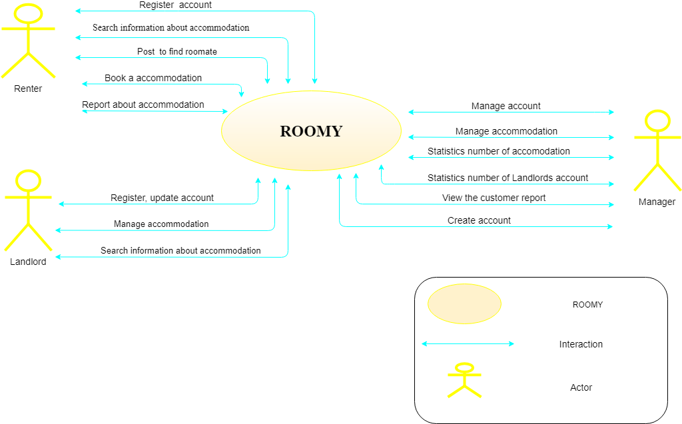

*Figure 1: System Context*

* 1. **Quality Attributes:**

|  |  |
| --- | --- |
| **Quality Attributes** : Availability | **ID** : QA01 |
| **Stimulus** | User turn off the device while server is running. |
| **Source(s) of the stimulus** | Administrator. |
| **Relevant environmental conditions** | Unexpected blackout. |
| **Architectural elements** | The system. |
| **System response** | The system will save the latest information and action that user did the last time |
| **Response measure(s)** | The system |

Table 3: Quality Attributes: Availability

|  |  |
| --- | --- |
| **Quality Attributes** : Performance | **ID** : QA02 |
| **Stimulus** | User want the system to respond their requests quickly |
| **Source(s) of the stimulus** | Administrator |
| **Relevant environmental conditions** | During the using process. |
| **Architectural elements** | The system. |
| **System response** |  |
| **Response measure(s)** | The system takes only 3-5 seconds to respond Administrator requests. |

Table 4: Quality Attributes: Performance

|  |  |
| --- | --- |
| **Quality Attributes** : Security | **ID** : QA03 |
| **Stimulus** | User whose the contract has expired access the system. |
| **Source(s) of the stimulus** | Administrator |
| **Relevant environmental conditions** | During using process. |
| **Architectural elements** | Network, the system. |
| **System response** |  |
| **Response measure(s)** | User can only see the events but cannot make any changes. |

*Table 5: Quality Attributes: Security*

|  |  |
| --- | --- |
| **Quality Attributes** : Compatibility | **ID** : QA04 |
| **Stimulus** | Administrators use the system in many devices. |
| **Source(s) of the stimulus** | Administrator |
| **Relevant environmental conditions** | During the using process. |
| **Architectural elements** | The system. |
| **System response** | Automatically change the size to fit with the device that administrator is using. |
| **Response measure(s)** | Users can user many different devices to access the system. |

Table 6: Quality Attributes: Capability

|  |  |
| --- | --- |
| **Quality Attributes** : Usability | **ID** : QA05 |
| **Stimulus** | Users can easily use the system at the first time. |
| **Source(s) of the stimulus** | Administrator |
| **Relevant environmental conditions** | During using process |
| **Architectural elements** | User guide, the system. |
| **System response** | Friendly 1user interface is presented |
| **Response measure(s)** | Users can use any functions of the system with just a few clicks and very easy to start using. |

Table 7: Quality Attributes: Usability

1. **Constraint:**
   1. **Business Constraint:**
      * Project will be started on: 15/08/2018
      * Project will be finished on: 5/12/2018
      * Project will be finished in: 120 days.
   2. **Technical Constraint:**

* **Technical for development:**
  + - * Language: VBA (Visual Basic for Applications).
      * Develop Tools: Visual Basic Editor, Macro.
      * Database: Microsoft Access 2010.
* **Environment:**
  + Operating system: Window 7, 8, 10
* **Other Constraints:**
  + Resource: 3 people.
  + Budget: Limited.
  + Time: The project must be completed within 4 months and 15 days frame.
  + Technology: Visual Basis Editor, Macro, Microsoft Access 2010.

1. **High level Architecture** 
   1. **Component and Connection View (C&C View):**

The diagram below shows the overview architecture including component and other related component. We have representations and behaviors for important components in the following sections.



*Figure 2: C&C View*

* Prose:
* One user accessed to system, the front-end interface will be displayed. With these front-end interfaces, user can go around the entire of the application. They can know which functions are on system easily. From that, database from server can be transacted to users by back-end working. The entire of website will have some main functions that will be presented in the table blow.
* The table below gives a brief explanation for the key elements in the C&C view:

***Table 8: Brief explanation for the key elements in C&C view***

|  |  |
| --- | --- |
| **Element** | **Description** |
| Homepage | The element will allow users to see homepage of tools. |
| Draft | The element will allow users to open [Drafting] Form |
| Select Text | The element will allow users to select type of administrative documents which they want editor. |
| Text Editor | The element will allow users to text editor. |
| Preview | The element will allow users to preview the text after they are text editor complete. |
| Save | The element will allow users to save data. |
| Print | The element will allow users to print document. |
| Export | The element will allow users to export document. |
| History | The element will allow users to open [History] Form |
| Select | The element will allow users to select type of administrative documents which they want view history. |
| Search | The element will allow users to search administrative documents. |
| Edit Text | The element will allow users to edit the old administrative documents. |
| Delete Text | The element will allow users to delete the administrative documents out of history. |
| Administrative documents management | The element is save all information about administrative documents. |

* 1. **Module view:**

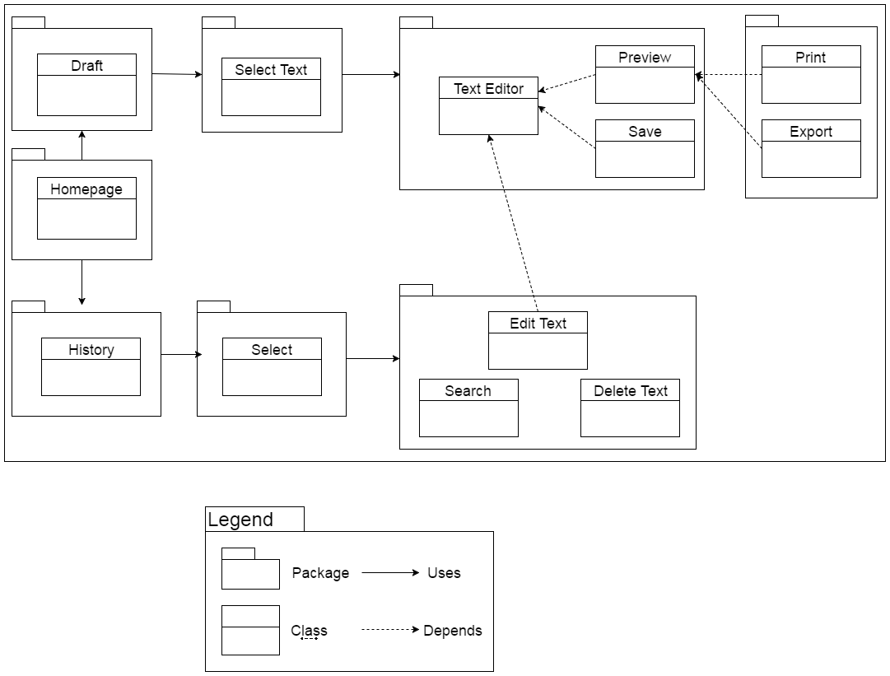

*Figure 3: Module View*

* Prose:
* These modules have relationship and interactive each other to create this tool. The functionality interact each other, relationship will be defined by arrows.

***Table 9: Brief explanation for the key elements in Module view***

|  |  |
| --- | --- |
| Element | Description |
| Homepage | This module is responsible for showing homepage of tool. |
| Draft | This module is responsible for showing [Drafting] form. |
| Select Text | This module is responsible for selecting type of administrative documents which they want editor. |
| Text Editor | This module is responsible for editing the text by form that user want to edit. |
| Preview | This module is responsible for previewing administrative documents after user is complete. |
| Save | This module is responsible for saving administrative document. |
| Print | This module is responsible for printing administrative documents. |
| Export | This module is responsible for exporting administrative documents. |
| History | This module is responsible for showing [History] form. |
| Select | This module is responsible for selecting type of administrative documents which they want view history. |
| Search | This module is responsible for searching administrative documents. |
| Edit Text | This module is responsible for editing the old administrative documents. |
| Delete Text | This module is responsible for deleting the administrative documents out of history. |

* 1. **Allocation view :**



*Figure 4: Allocation View*